SPRINT 2

|  |  |
| --- | --- |
| TEAM ID | PNT2022TMIDTMID44629 |
| PROJECT NAME | GAS LEAKAGE MONITORING AND ALERTING SYSTEM FOR INDUSTRIES |

OPEN THE IOT PLATFORM IN IBMCLOUD CREATE THE DEVICE :

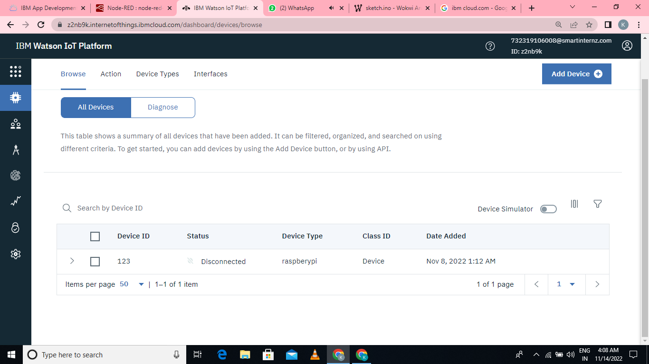

OPEN NODE RED

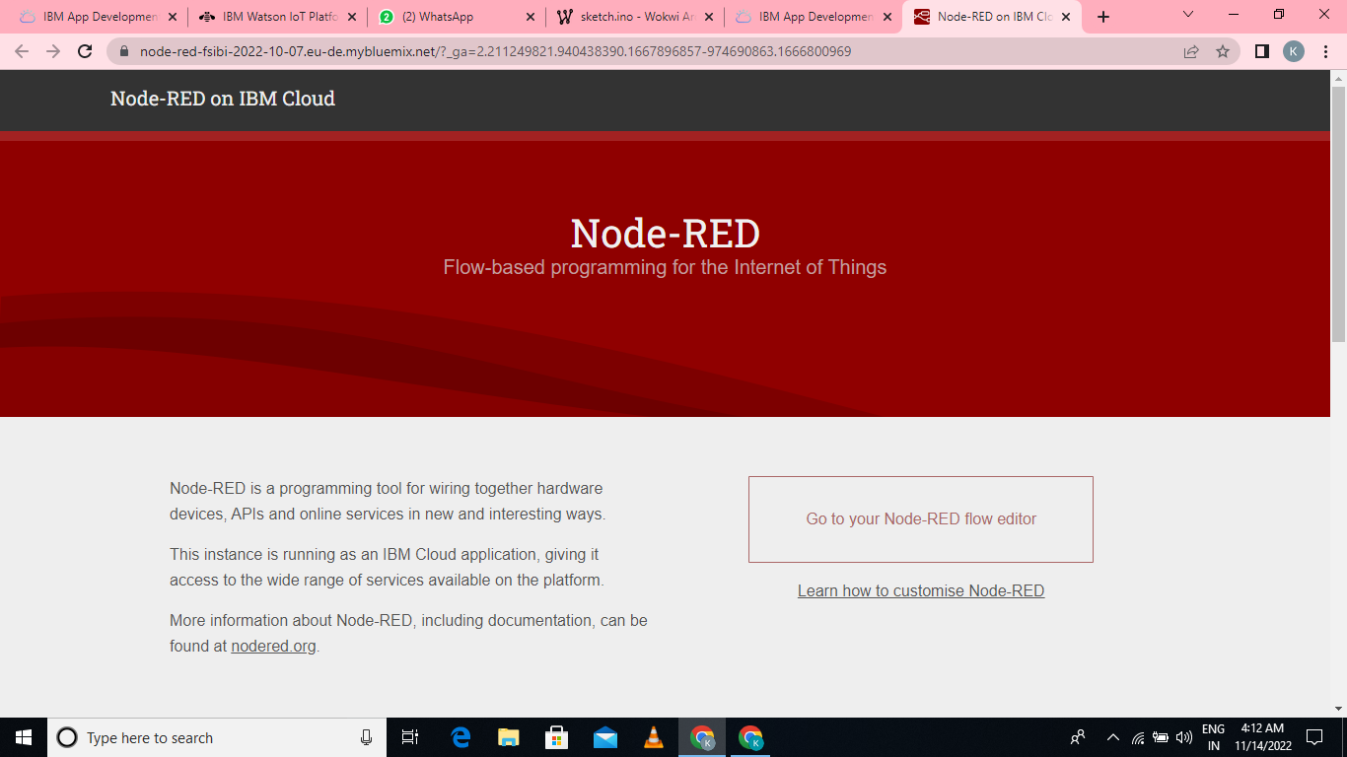

CONNECT THE WOKWI TO IBMIOT:

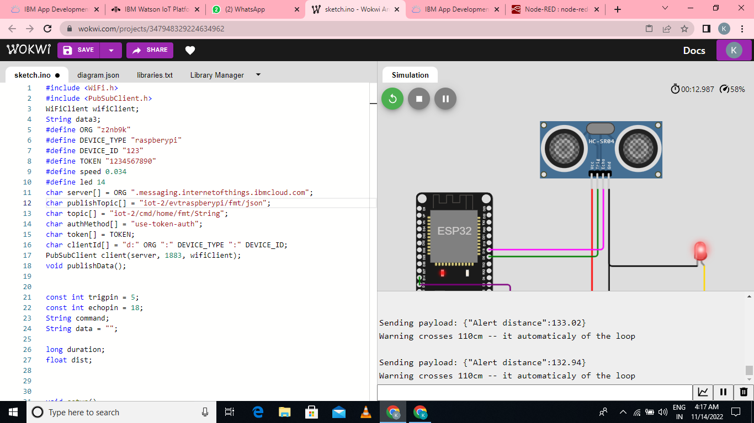

HERE IT SHOWS THE OUTPUT OF CONNECTED DEVICE:

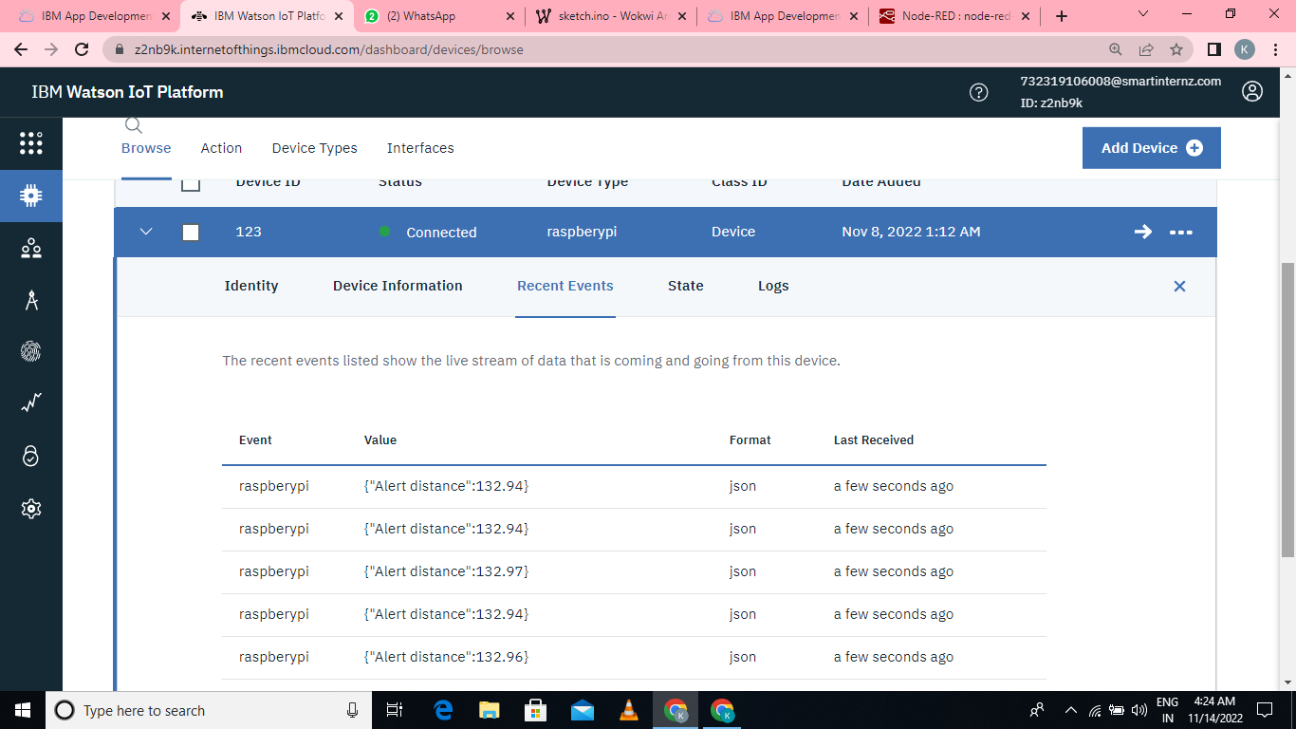

FINALLY IN NODE RED IT SHOWS THE OUTPUT:

